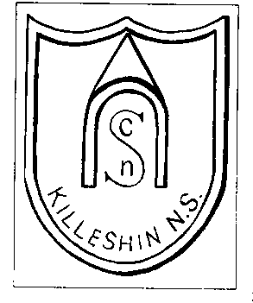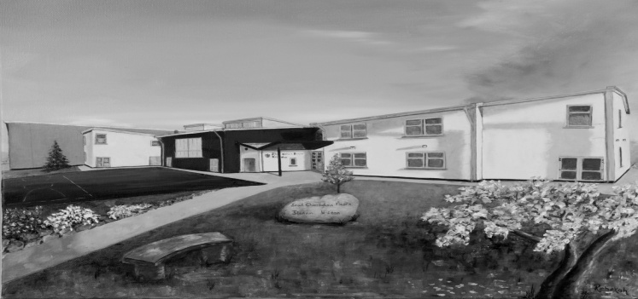
Killeshin N.S., Killeshin, Carlow. Guthán: 059/9147852
E-Mail: principal@killeshinns.ie

Scoil Chomhgháin Naofa Data Protection Policy
Introduction:
This policy was formulated by the Principal, Staff and Board of Management of Scoil Chomhgháin Naofa, Killeshin.The purpose of the policy is to identify the records required to be retained by the school and to ensure confidentiality and manageable procedures in relation to access to such records by parents and stake holders.
Rationale:
- A policy on data protection and record keeping is necessary to ensure that the school has proper procedures in place in relation to accountability and transparency;
- It is good practice to record pupil progress so as to identify learning needs;
- A policy must be put in place to ensure our school complies with legislation such as;
  - Education Act, (Section 9g requiring a school to provide access to records to students over 18/parents);
  - Education Welfare Act – (requiring a school to report school attendance and transfer of pupils)
  - Child Care Act 1991
  - Children’s Act 1997
Relationship to School Ethos: We promote openness and co-operation among staff, parents, management and pupils as a means towards providing the caring environment through which a child can develop and grow to full potential.
Aims/Objectives:
  - To ensure the school complies with legislative requirements;
  - To clarify the types of records maintained and the procedures relating to making them available to the relevant bodies;
  - To put in place a proper recording and reporting framework on the educational progress of pupils;
  - To establish clear guidelines on making these records available to parents (and pupils over 18);
  - To stipulate the length of time (minimum 7 years) records and reports will be retained;
Guidelines:
The Principal assumes the function of data controller and supervises the application of the Data Protection Act within the school.The data under the control of the Principal comes under the following headings.
Personal Data:
This data relates to personal details of the students such as name, address, date of birth, gender, home telephone and mobile contact details, ethnic origin, nationality, religious belief, medical details, dietary information, (PPSN in the case of students with special educational needs).
Student Records:
Student records are held by each class teacher and also in the administration office. Student records contain;-
  - Personal details of the student
  - School report cards
  - Psychological Assessments
  - Assessment results carried out by professionals to assist teaching and learning (e.g. results of psychiatric reports; occupational therapy reports; speech and language assessments; etc. ).
  - Standardised Test Results
  - Attendance Records
  - Screening Tests such as M.I.S.T., N.R.I.T., Quest, Dyslexia Screening Tests etc.
  - Records of students who have been granted exemption for the study of Irish.
  - Teacher-designed tests. Each class teacher designs his/her own test template
  - Diagnostic Tests Reports
  - Individual Education Plans, Individual Pupil Learning Plans and records of meetings with the stakeholders regarding these plans;
  - Learning Support/Resource Data such as records of permissions/refusals to allow children access to LS/RT services in the school
  - Portfolios of student work e.g. Projects/Art and achievements on diagnostic tests.

Staff Data:
Name, address, date of birth, contact details, payroll number, pension details, attendance records, qualifications, school records, references, Garda vetting certificates etc.
Administrative Data:
  - Attendance Reports, Roll Book, Registers; Class files; Pupil Profile files; Enrolment applications; baptismal certificate copy (where applicable); birth certificate copy
  - Correspondence between parents and teachers.
  - Accident Report Book detailing injury and treatment applied
  - Administration of Medicines Indemnity Forms
  - Late arrivals record
  - Records of books borrowed from school library
  - Pupil behavior records and Records of allegations/ incidents of bullying and alleged bullying;(manually recorded notes)
  - Records kept in line with Childrens First Procedures (Child Protection)
Access to Records:
The following will have access where relevant and appropriate to the data listed above where pupils are identified by name:
  - Parents/Guardians
  - Past Pupils over 18
  - Health Service Executive staff
  - National Educational Psychological Service
  - National Education Welfare Board
  - Occupational Therapists or Speech Therapists working with pupils
  - Designated School Personnel
  - Department of Education and Science (where necessary)
  - First and Second level schools (where relevant)
  - Scoil Chomhghain Naofa Board of Management
With the exception of child protection-related data which is governed by “Childrens First Guidelines and Procedures 2011”, data on attendance, (governed by NEWB) and data regarding achievements in literacy and numeracy, (governed by National Strategy for literacy and numeracy), parental authorisation must be provided by parents in the event of data being transferred to outside agencies.Outside agencies requesting access to records must do so in writing.Parents/Guardians of current pupils can make such a request either by phone or in writing. Past pupils and parents of past pupils seeking data must do so in writing.
A standardised school report form is used which is issued by post in June to all parents who supply a stamped addressed envelope. Results of standardised testing are included in this report.
Storage:
Records are kept for a minimum of 7 years. Standardised tests booklets are shredded after one year but the percentiles are kept on record until past pupils reach adulthood, (21 years of age).
  - Pupil profiles for individual pupils are kept by each teacher in his/her individual classroom and passed on to the next teacher as the child moves to the next class.
  - As children pass to second level their personal records are stored in the school (labeled with the school year in which they completed 6th class) for a period of time (7 yrs minimum).
  - All completed school roll books and school registers are stored in the school indefinitely. Access to these stored files is restricted to authorised personnel only. For computerised records, systems are password protected .
Success Criteria:
  - Compliance with Data Protection Act and Statute of Limitations Act
  - Easy access to records
  - Manageable storage of records.
Roles and Responsibilities:
The school staff, under the direction of the Principal, will implement and monitor this policy. Individual teachers will design, administer and record in-class testing. The Principal will ensure records are maintained and stored.
Review/Ratification/Communication:
This policy was reviewed and ratified on 14/03/2024.
It will be reviewed in May 2026 but may be reviewed and amended earlier if it becomes necessary.

Signed _______________________.
Chairperson Board of Management.

