Scoil Chomhgháin Naofa Killeshin

Handwriting Policy

Introduction Statement and Rationale

Introduction Statement
Handwriting is a skill which, like reading and spelling, affects written communication across the curriculum. Children must be able to write with ease, speed and legibility. We support the current research which outlines the benefits of teaching cursive handwriting. Cursive handwriting teaches pupils to join letters and words as a series of flowing movements and patterns. The development of this fluid style when mastered allows children to apply their energy into the content of their writing as opposed to the formation of the letters themselves. Handwriting skills are taught regularly and systematically throughout the school.

Rationale
It is hoped that this school plan will be a useful tool for teachers providing them with clear guidance in the teaching of handwriting and ensuring consistency and continuity in practice throughout the school. We attach a high priority to giving children the skills to present their work neatly and legibly and children’s self-esteem and confidence is increased when they are able to produce well- presented work of which they can be proud.

Aims:
At Scoil Chomhgháin Naofa our aims in teaching handwriting are:
- To enable children to write in a consistent, well presented and legible format.
- To have a consistent approach across the junior and senior classes when teaching
handwriting.
- To ensure that from third class to sixth class children are using a cursive writing style.
- To make sure all children know the difference between lower and upper case letters.
- To ensure the skills taught in the junior classes continue to develop in the senior classes.
- To adopt a consistent approach towards handwriting by all adults when writing in
children’s books, on the whiteboard or on displays / resources.

Implementation

Children will be taught to:
- hold a pencil correctly.
Children should be encouraged to use a tripod pencil grip, where the pencil is gripped between the index finger and the thumb. The middle finger is then used to support the underside of the pencil as shown below.

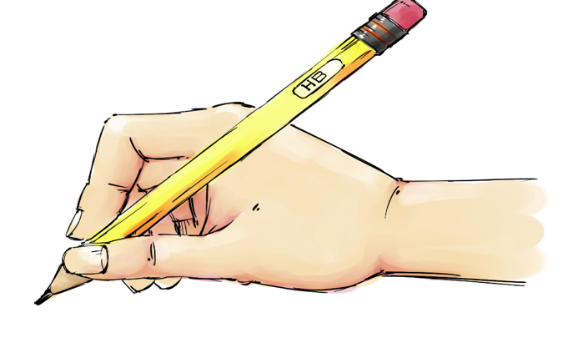

- adopt the correct posture when writing.
Children should be encouraged to adopt the correct writing position as shown below.

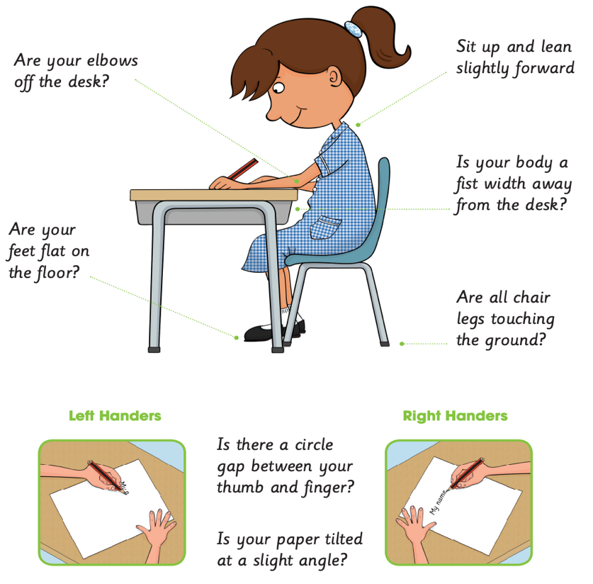

- write from left to right and from top to bottom of the page
- start and finish letters correctly in a cursive style from term 3 in third class
- form regularly sized and shaped letters
- use regular spacing between letters and words
- take a pride in their written work and the overall presentation.

The Just Handwriting Programme will be followed in all classes to ensure continuity and consolidation of correct letter formation.

- The precursive script adapted by Scoil Chomhgháin Naofa in Junior-2nd Class is as follows:

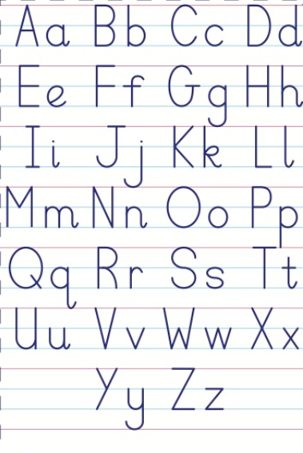

- The cursive script adapted by Scoil Chomhgháin Naofa in 3rd -6th class is as follows:

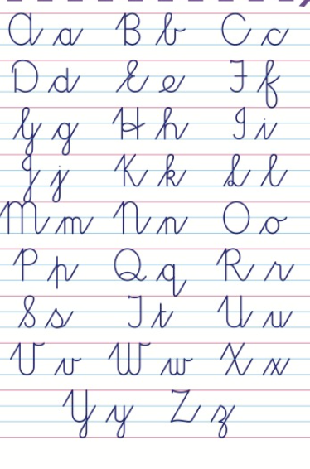

Junior Infants

- In Junior Infants children will be encouraged to develop gross motor control through the
use of large equipment for mark making such as big chalks, paint brushes, finger paints, shaving foam etc.
- They will develop their fine motor skills and use a range of mark making tools such as pencils, markers and crayons.
- The children will practice prewriting skills using marla, playdoh, colouring and cutting and pasting activities . They will be encouraged to talk about shapes and movement.
- Lower case letter formation is taught in conjunction with the Jolly Phonics programme.
- They will practise the main precursive handwriting movements for the lowercase letters using the formation as outlined in Appendix 1.
- Our aim is that by the end of Junior Infants, all children hold a pencil correctly, have good posture and form all letters and numbers correctly.
- Errors in pencil grip and letter formation will be immediately addressed, modelled and corrected.

Senior Infants

- In senior infants the children will continue to work on the lower case letter formation following the Just Handwriting Pre Cursive Handwriting Programme.
- Correct pencil grip and posture will be reinforced and all lower case letters will be monitored for correct formation.
- The children will learn the upper case formation of all letters using the formation as outlined in Appendix 2.
- Children will be encouraged to use the correct sizing and spacing for the introduction to copy work. Finger spacing between words will be introduced and practiced.

First and Second Class
- In first and second class the lowercase and uppercase letter formation will be consolidated using the Just Handwriting Pre Cursive Handwriting Programme.
- The children’s pencil grip and posture will be monitored and rectified where necessary.
- At this stage emphasis will be on sizing, spacing and neat presentation.

Third Class
- In third class the children will be introduced to cursive writing.
- They will learn all lowercase and uppercase letter formation in cursive handwriting.
- Pencil grip and posture will be monitored and corrected.
- Presentation using margins with red pen, headings, date and numbers in margins will be introduced at this stage.
- All written copies will follow the same layout as outlined in Appendix 3.

Fourth Class
- In fourth class children will continue to work on the correct formation of lower and upper case letters in cursive style improving on the sizing and spacing and legibility of their handwriting.
- As the children gain confidence and write legibly, they will begin to use a blue handwriting pen such as Berol/Uniball/Staedler or an erasable handwriting pen.
- It is expected that all children in term 3 of fourth class will be handwriting using blue handwriting pens.
- Children will write in cursive style across all areas of the curriculum.

Fifth Class
- Children will continue to practice their cursive writing in fifth class and write legibly and present their work neatly using blue handwriting pens and red pens for margins and titles.
- Children will be reminded about the correct pencil grip and posture.
- If any child is not on track to reach these expectations, they will receive additional support through small group intervention groups.

Sixth Class
- By sixth class children will use cursive handwriting using flowing movements and patterns.
- This handwriting should be demonstrated in all writing across the curriculum.
- Writing should be fluid in style to allow children to apply their energy into the content of their writing as opposed to the formation of the letters themselves.
- The children will develop a legible, fluent, personal style of handwriting.
- They will continue to follow the presentation standards using margins, date and headings.
- In preparation for secondary school, the children will begin to use biro in term three of sixth class.

Equipment
Junior/Senior Infants: Larger triangular pencils, chubby crayons and large lined pages in their handwriting book and practice copy. Unlined pages in copies, progressing to wide lined copies. Just Handwriting Pre-Cursive Book and Practice Copy.
1st Class Thinner triangular pencils and 15 A copies. Just Handwriting Pre Cursive Book 1st Class.
2nd Class Sharp pencils, blue lined copies, Just Handwriting Pre Cursive Book 2nd Class.
3rd Class Sharp pencils, blue lined copies, red biro for margins. Just Handwriting Cursive Book 3rd Class.
4th-6th Class Blue handwriting pen, red biro for margins, blue lined copies. Just Handwriting Cursive Books/B4 Narrow Handwriting Copies.
No biros are permitted for handwriting until the last term in 6th Class.

Assessment
- A uniformed and consistent pre-cursive and cursive handwriting style should be displayed throughout the school.
- This will be evident in handwriting displays and in copies and textbooks. Teacher observation of posture and pencil grip will be necessary to rectify any difficulties that the children are experiencing.
- Teacher tasks and feedback will inform children of any changes they need to improve the legibility of their writing.
- Self-assessment options are on the bottom of each page of the Just Handwriting programme and the children can assess how well they completed their handwriting activity.

Success Criteria
The practical indicators of the success of this policy include:
- consistent teacher observation of pupils’ handwriting in copybooks at school and also in homework
- children will be entered in regular school and national handwriting competitions
- continuous displays of the children’s writing in the classrooms and school
- positive feedback from staff, students, parents and inspectorate

Roles and responsibility of the policy
The Board of Management, Principal, Ms Keating have been responsible for supporting, developing, implementing and evaluating this policy.

Implementation Date:
The policy was implemented in September 2023.

Timetable for Review This policy will be reviewed in 2024/2025 and biennially thereafter.

Ratification & Communication
The plan was circulated to the members of the Board of Management prior to the meeting in ______________and was formally ratified on_____________. Notification that the plan is available for viewing will be communicated to the parents in the School Communication. It will be available for viewing by appointment in the office. Signed: ________________________ Date: _______________

Appendix One Pre Cursive Letter Formation

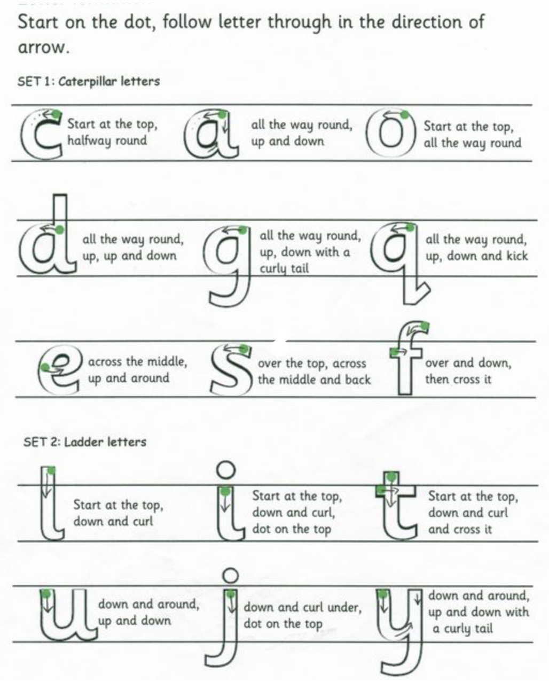

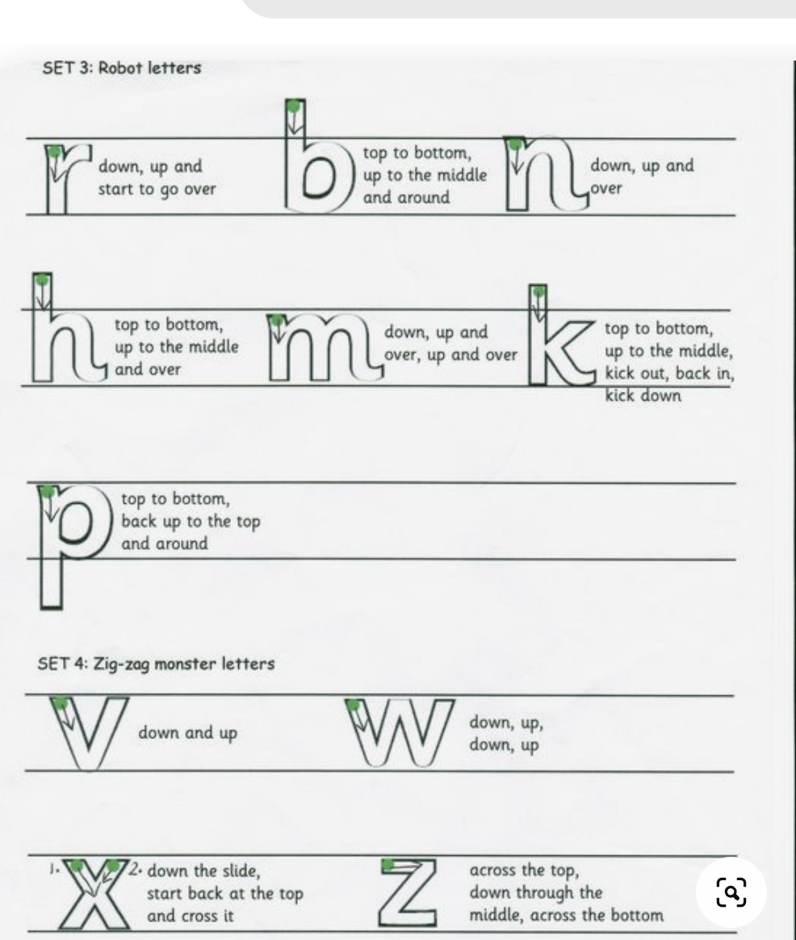

Appendix Two Upper Case Letter Formation

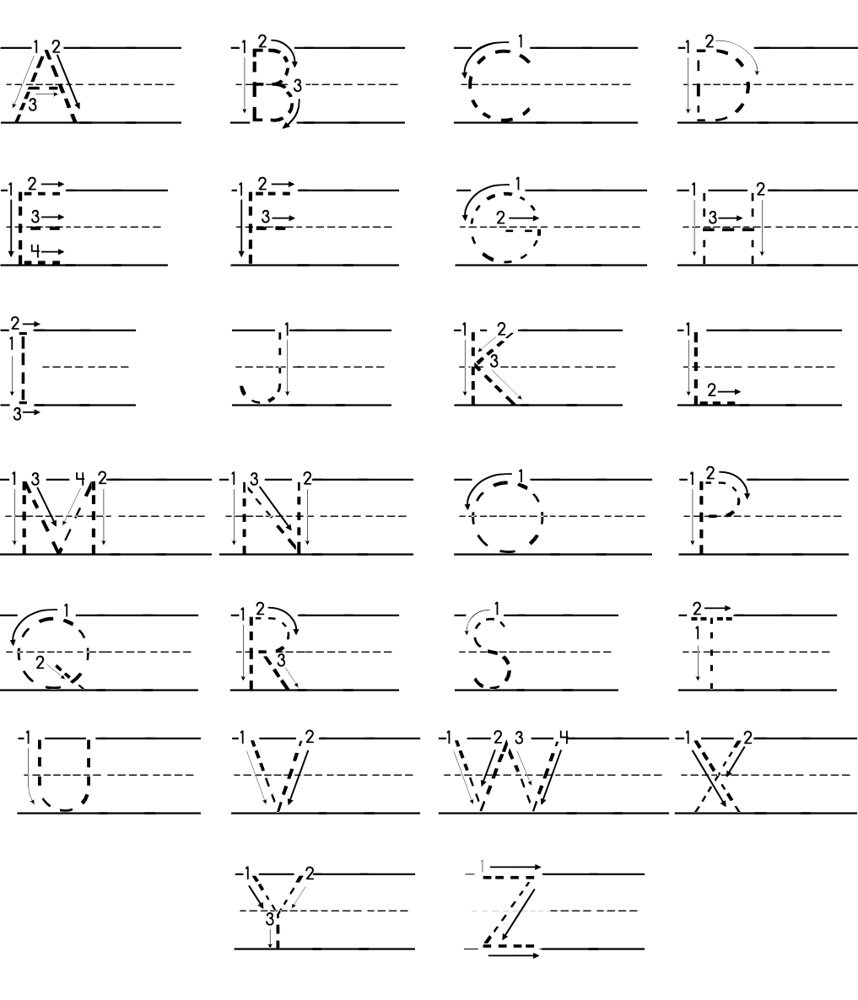

Appendix Three Presentation Expectations

