Introduction:
Killeshin N.S is currently developing a Wellbeing Promotion Process within the school, which is supported by the Department of Education and Skills (DoE) and the Health Service Executive (HSE). It is strongly supported by the “Health Promoting Schools” Model.
“Wellbeing is present when a person realises their potential, is resilient in dealing with the normal stresses of their life, takes care of their physical wellbeing and has a sense of purpose, connection and belonging to a wider community. It is a fluid way of being and needs nurturing throughout life.” (WHO), 2001).
Killeshin N.S has a duty to provide the best quality and the most appropriate education in order to promote the wellbeing of our students. We also have a duty to protect students in our care at all times from any potentially harmful, inappropriate or misguided resources, interventions or programmes.
Killeshin N.S provides a two-tiered support to pupil well-being.
1. Whole School Approach
2. Individual Support through Student Support Team

Whole School Approach to Well-being
A multi-component, preventative, whole school approach to the promotion of well-being, with interventions at both universal and targeted levels, is the priority for Killeshin N.S. This whole school approach involves all members of the school community engaging in a collaborative process of change to improve specific areas of school life that impact on well-being.
By adopting a whole school approach Killeshin N.S aims to produce a wide range of educational and social benefits for our pupils, including improved behaviour, increased inclusion, improved learning, greater social cohesion, increased social capital and improvements to mental health.
This whole school approach supports the integration of systems within the school community. This creates capacity to be reflective and responsive to the needs of our school and the individuals who are part of the school community.
Central to this is the role of Killeshin N.S staff and the importance of building professional capacity to engage in a reflective process to implement and sustain well-being policy and strategies from within.
Killeshin N.S is in a unique position to promote well-being, and social and emotional learning, and ensures a whole school approach to well-being promotion and early intervention, especially when considering appropriate use of external supports and services.
Students flourish where there is a whole school approach to supporting their growth and where there is a shared belief in their potential for development, learning and well-being. Killeshin N.S is responsible for providing an environment that nurtures and supports students.

Benefits of promoting pupil well-being in Killeshin N.S
By implementing a whole school approach to well-being the benefits include.
• Better learning results for pupils
• More done to promote staff health
• A co-ordinated approach to social, physical and environmental needs
• Increased pupil self-esteem
• Lowered incidence of bullying
• School environment is safer and more secure
• Better understanding of schools’ health aims
• Improved relationships within the school
• More involvement of parents/guardians
• Better use of outside agencies
• Pupils receive better quality education

The Department’s Wellbeing Policy Statement and Framework
The Department’s Wellbeing Policy Statement and Framework for Practice assists schools in ensuring that well-being promotion is embedded within the school’s existing practice. The school’s review and development process using the Wellbeing Policy Statement and Framework for Practice provides guidance and practical resources to assist in the further enhancement of whole school approaches to well-being promotion in the areas of:
- Culture and environment
- Curriculum (teaching and learning)
- Policy and planning
- Relationships and partnerships

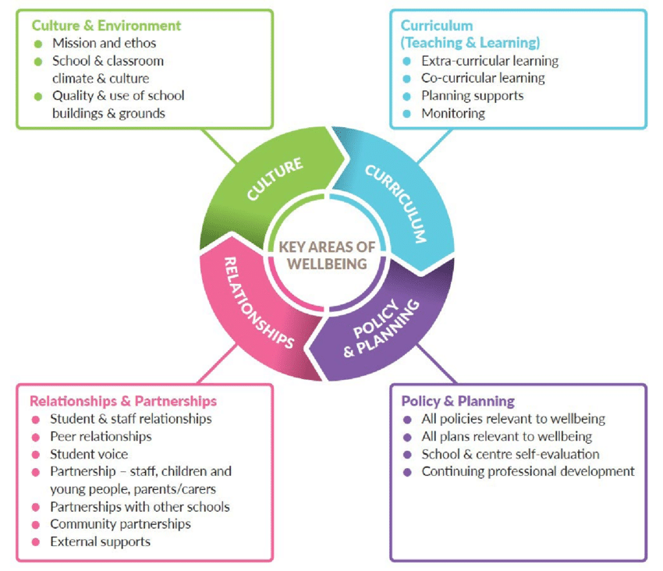

Environment
Killeshin N.S aims to foster an environment that enhances competence and well-being; one that consciously fosters warm relationships, encourages participation, develops pupil and teacher autonomy and cultivates clarity about boundaries, rules and positive expectations.
Killeshin N.S provides a safe, secure and stimulating environment that encourages and supports pupils, staff and members of the whole school community, both in and out of school. We encourage and promote self-esteem and self-confidence by providing opportunities for all members of the school community to contribute to school life. The school community is encouraged to make healthy choices and to take responsibility for their own health.
Killeshin N.S continues to provide a climate in which good relationships, respect and consideration for others prosper, and where individuals are encouraged to make a vital contribution through their personal skills and qualities.

Curriculum and Learning
The teaching and learning in Killeshin N.S aim to be democratic, inclusive, engaging, differentiated, fostering expectations of high achievement and providing opportunity for success. We place a deliberate focus on the development of emotional and social competencies, through our “Friends for Life Programme.”
The SPHE curriculum in Killeshin N.S strongly supports the social and emotional well-being of our pupils, by placing and emphasis on children’s social and emotional skills, attitudes, behaviour and therefore learning performance.
Killeshin N.S adheres to statutory requirements and is accessible to all pupils. We provide challenges for pupils and staff through a wide range of physical, academic, social and community activities. Policy and Planning Policies are written documents which support the everyday running of the school through active implementation on a day-to-day basis. They form the background script by which the school navigates its way. They are developed and implemented by the whole school community, not just by one or two people.
Killeshin N.S regularly reviews our school policies for staff and pupils that are in accordance with the school aims, philosophy, vision and ethos.

Partnerships
Killeshin N.S continues to develop strong partnerships with parents/guardians and the wider community, which is a central part of the well-being process.
We efficiently engage with appropriate agencies and specialist services to advise, support and contribute to health and well-being, teaching and learning

Role of teachers
It is essential that all staff continue to develop their competence and confidence in the promotion of wellbeing. The qualified classroom teacher is the best placed professional to work sensitively and consistently with students and she/he can have a powerful impact on influencing students’ attitudes, values, and behaviour in all aspects of well-being education. This can be achieved through accessing continuing professional development (CPD) which includes the sharing of expertise and learning and having opportunities to model and engage in collaborative working.
The curricular elements of well-being promotion will be delivered by staff who are trained for this purpose having completed relevant CPD.

School Based Initiatives that Promote Well-being
Killeshin N.S implements a number of programmes and initiatives throughout daily school life that support the well-being of our pupils; this list is not exhaustive.
• Aistear: The Early Childhood Curriculum Framework (NCCA, 2009) which encompasses four
themes, Well-being, Identity and Belonging, Communication, Exploring and Thinking. This
programme runs in Junior Infants.
• Project based learning from 3rd class to 6th class
• SPHE Curriculum (RSE Month – March- April (year1), Stay Safe Month – March-April, Friendship Month (Anti Bullying) – teacher discretion.
- Friends for Life Programme (Senior Classes)
- Creative Mindfulness ( Middle Classes)
- Amber Flag for Wellbeing (whole school initiative)
- Continuum of Support Model
- Walk Tall Programme (whole school)
- Weaving Wellbeing (whole School, as required)
- Talk About Programme (SET)
- Incredible Years (SET)
- Zones of Regulation (SET)
- Cognitive Behavioural Training (SET)
- Student Committees: Green School Committee, Amber Flag for Wellbeing Committee
- Outdoor Learning
- Internet Safety Workshop –
- G.A.A. training initiative (junior infants-second class))
- Rugby training initiative (third class-sixth class)
- Cycling Road Safety Initiative (senior classes)
• School subsidised swimming lessons – 8 week block for all pupils (first and second class)
• Healthy Eating Policy (whole school approach)
• Active Schools Week
• Whole-school assemblies
• Themed Weeks (e.g. Maths Week, Science Week, Book Week, Art and Craft etc)
• Promoting the Arts – Instrumental Music, School Choir, School Musicals, Art and Craft Display
• After School Clubs
• Communicating with National Council for Special Education (NCSE) to gain SNA access for pupils
• Communicating with CAMHS for advice and support when required
• Barnardos – referral from school for support for pupils and families
• Education Welfare Officer – support for pupils with poor attendance
• Links with HSE personnel e.g. Spraoi Centre in Portlaoise (Speech and Language, OT, Psychology)

Killeshin N.S well-being protective factors
In Killeshin N.S well-being protective factors include:
• Positive relationships with peers and teachers - including positive teacher classroom management strategies and a sharing of positive behaviour management practices with parents
• A sense of belonging, security and connectedness to school through a positive school climate and participation in school and community activities
• Opportunities for social and emotional learning including the development of attention and planning, self-awareness, self-management, relationship and responsible decision-making skills
• opportunities for the development of knowledge and skills providing a sense of mastery and self- efficacy
• Fostering expectations, recognising contributions, effort and achievement and providing opportunities for success
• Well-being of school personnel
• Protocols and support systems that proactively support children and their families should difficulties arise
• Opportunities to develop the necessary skills to cope with using online technology in a safe and appropriate way
• Opportunities to develop skills to manage stress that may be linked to school work Well-being risk factors in our school setting, well-being risk factors include:
• Disengagement, absenteeism, isolation and alienation
• Violence/aggression, bullying and relationship difficulties
• Low achievement/learning difficulties/special educational needs including social, emotional and
behavioural needs
• Cultural differences
• School transitions
• Poor connection between family and school
• Harsh and inconsistent discipline, lack of opportunity to develop social and emotional learning, including problem solving and coping skills.

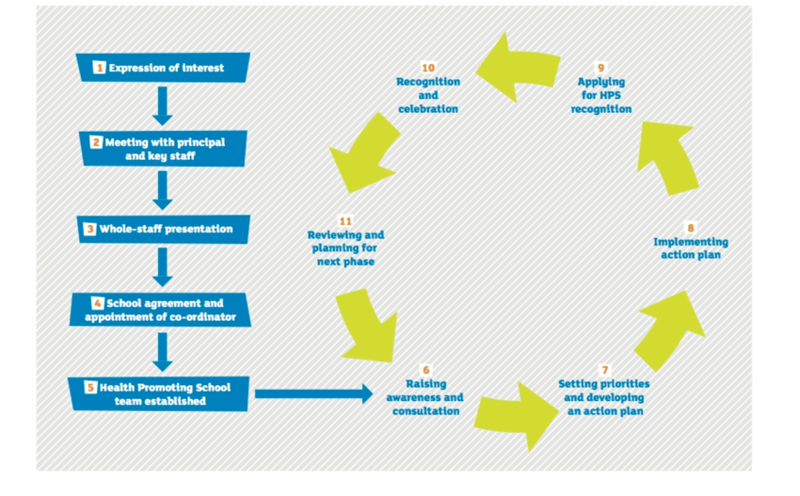

Supporting Individual Pupils: The Student Support Team (SST)
The Student Support Team in Killeshin N.S looks after the overall general well-being of students. While it is limited to and by school time, we realise that many external issues impinge on the development of students. The purpose of an SST is to provide for students who have a greater need for a higher level of intervention from the school community. The SST is a visible representation of the school’s understanding and valuing of each student as an individual.
The SST ensure effective implementation of a whole school approach which has well-being promotion as part of its responsibility. The Student Support Team (SST) consists of the schools’ Continuum of Support Team, Principal, Deputy Principal and Assistant Principal 1.
The SST meet regularly and discuss the needs of pupils in the school as a whole, under the continuum of support model. Children may be identified through this process, who would benefit from further support in school, at home and/or from external agencies/bodies.

Objectives and Rationale for SST:
Students who experience difficulties in life will find it difficult to have cognitive space for learning. Therefore the rationale of the SST is to strive to care in a genuine way to improve the lives of students and thereby ensure access to the curriculum and learning.
The SST undertake the following.
1. To liaise with external professionals about the welfare of the child
2. To liaise with the parents/ guardians of the child
3. To share information in a confidential setting
4. To coordinate a single transparent response to the care needs of a student
5. To review and monitor the students with care needs
The SST is a school-based student services structure that uses resources and staff time efficiently. SST
increases student achievement by linking educational interventions with needed support services. SST meet regularly to discuss many students at a single meeting and develop strength-based intervention plans. Professional services are combined with youth development activities and programs to form “packages of support” for students and families.

School Support Team and Code of Behaviour:
The School Support Team and the Code of Behaviour work together to provide the structure and the care that is necessary for the student to benefit from school. The student may be in the School Support Team and the Disciplinary system at the same time.

Members of the School Support Team:
The core School Support Team is made up of staff and professionals that have direct involvement in the care issues of pupils and various other members depending on the students being discussed.
The following is a list of initial core members.
- Principal:
- Deputy Principal
- Assistant Principal 1: Head of SET
- Continuum of Support Team who provide one to one and group support to pupils in need
School Support Team meetings are often used to develop and implement positive programs during school.

Student referral to the School Support Team:
All staff in the school community have a responsibility to be observant of the care needs of the student. Individual staff members need to trust their intuition regarding a student who needs support, outside of what can be provided in the classroom setting. It is in the interest of the student to have a clear referral system. The process of referral into the school support team will be outlined clearly to staff below.
The system below regarding referral should be maintained:
This system is as follows:
- The class teacher will refer a student directly to the School Support Team member assigned to his/her class.
- School support team member will forward information to principal.
- The principal will then liaise with the relevant members of the School Support Team. A staff member or parent may also refer a student to the Principal or Deputy Principal.
- Administrators and staff members may refer a student directly to the School Support Team
- During parent/guardian meetings following disciplinary actions, teachers often identify the Student Support Team as a resource to help address concerns.
- Parents and guardians who would like to request support may contact a staff member who will advocate for them
Following a referral to the school support team, the teacher will typically call home to arrange a meeting with the parents/ guardians to discuss concerns. The SST member enquires about the pupil’s talents and interests, shares with the parent/ guardian that the School Support Team may be able to help the student to be more successful at school.

Once a student is referred to the Support Team:
- Support plan is initiated for the child
- Intervention plans are developed, and a specific staff member is assigned to coordinate the interventions for each student under the supervision of the School Support Team.
- Health, mental health, and culturally appropriate community resources that may be needed are identified during the meeting.
- The team addresses attendance concerns along with the National Educational Welfare Board.
- The team addresses specific learning needs along with professionals such as National Educational Psychology Service (NEPs), HSE personnel (Primary Care Team, Assessment of Need Team, Early Intervention Team, School Age Team
- Cases are brought back to the School Support Team for review.

Documentation and communication of Support Plans:
- Agendas and minutes are shared, however individual children are not identifiable.
- Support plans are drafted, shared with parents for consultation, and then finalised before a
programme of support commences.
- Support plans are securely kept in child’s file.
- Any confidential information or information which evokes the implementation of Child Safe Guarding Policy are dealt directly by the Designated Liaison Person – DLP, (or Deputy DLP in their absence), and communicated with parents/guardians.
- Because multiple students are discussed at Student Support Team meetings, students and caregivers do not attend Student Support Team meetings or have access to confidential information. Individual support plans drafted for specific children will be shared with parents.

Confidentiality
An essential element of the School Support Team is maintaining clarity around the boundaries of confidentiality. It is essential for all members of the team, as well as all staff and pupils, to understand the concept of confidentiality in regard to child protection guidelines.

Communication
Clear communication is essential. A person who refers a pupil does not necessarily need to know the details of what has been discussed in relation to the student, but they need to be assured that the student is being cared for.

Essential Elements of the Student Support Team
- Child centred/ advocate for the student
- Non-judgmental
- Solution focused as opposed to problem focused.
- Supported by staff, senior management and BOM
- Optimistic and hopeful
- Accountable through record keeping

School Support and School Support Plus
These lists are intended to inform the staff about students who are identified as requiring additional support and to communicate the work of the student support team.
When a student is on the list, staff will be aware that a key support team member is dealing with that student. This list will also heighten the awareness of staff to any issues arising with the student in the classroom. It is essential to note that even if a student is on the list that normal code of behaviour applies at all times.

Meetings
The ethos of consistent and regular meetings is central to ensuring the success of the student support team. To formalise and emphasise care of the student, members of the student support team will meet weekly on scheduled dates in the school calendar. Additionally, the student support team can conduct meetings at unscheduled dates as needs be e.g. when new children that need support enrol throughout the year.

Programmes and/or External Facilitators
Use of programmes and/or external facilitators can play a role in supplementing, complementing and supporting a planned comprehensive approach to well-being promotion. Programmes and/or external facilitators accessed in Killeshin N.S
- Are part of a whole school approach and address an identified need
- Are delivered to class groups with the involvement of school staff and the appropriate involvement of parents/carers
- Enhance protective factors which predispose students to positive outcomes in the face of adversity such as: facilitating supportive adult-pupil relationships, strengthening life skills, helping students believe in their capacity to overcome hardship and building a sense of mastery over life circumstances
- Adopt a planned implementation process, for example, incorporate needs analysis, use evidence informed programmes and track and evaluate outcomes for students
- Are implemented and used in a school in a sustained way over a number of years in order to bring about lasting effects and benefits
Please refer to Appendix 2 for checklist

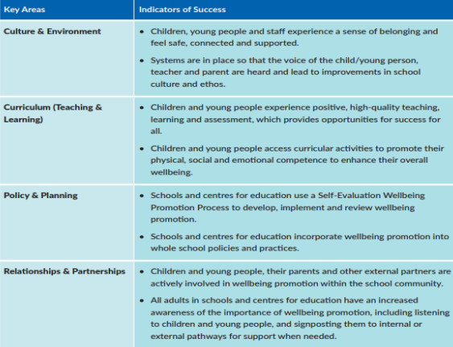

Evaluation
The Killeshin N.S team need to be reminded that they need to take care of themselves as well as the students. Reflection and evaluation are necessary. Evaluation forms will be used for this purpose at the end of the academic year.
Evaluation of the pupil well-being programme will take place under the School Self-Evaluation model.

Link with other policies in the school
The Student Support Team process will link in with the following policies already in existence in the school:
- Code of Behaviour links the discipline structure to the work of the care team
- Anti-Bullying Policy may link with the care team in supporting both the victim and the instigator
- Critical Incident Policy. This is an important policy for the care team as it outlines procedures that a school uses when faced with a trauma such as death of a student.
- Enrolment Policy. It is important to name the care team as part of the school’s commitment to caring for the student and to alert parents to the fact that those students can be referred for internal support.
- Continuum of Support Policy. This policy reflects the fact that students attending learning support or who have special needs may need the support of the care team.
- SPHE Policy. The social, personal and health education of students is an integral part of the curriculum and links in with the care team and guidance.
- Staff Induction. All new staff members are trained in the method of referral and the relevance of the red and amber list.

Appendix 1: Well- Being Framework

Key Area 1 – Culture and Environment
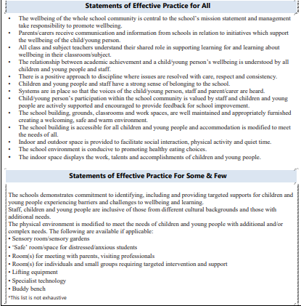

Key Area 2 – Curriculum (Teaching and Learning)
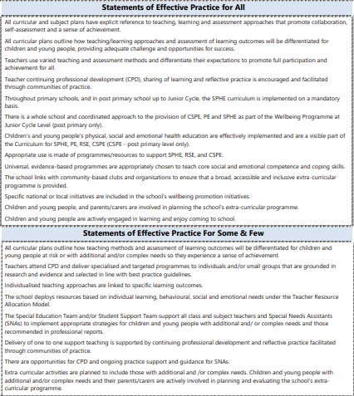

Key Area 3 - Policy and Planning
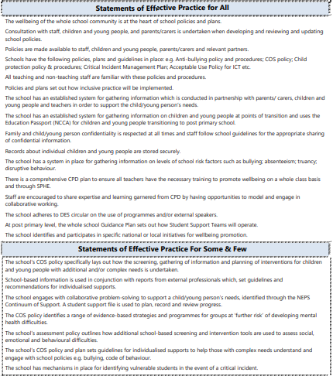
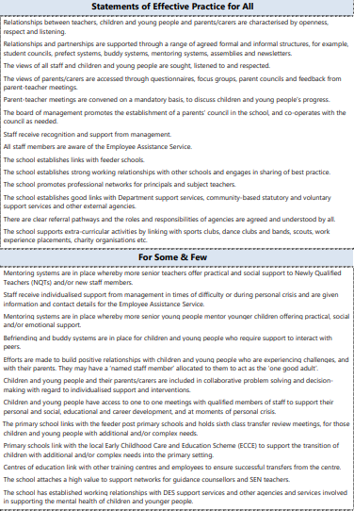
Key Area 4 - Relationships & Partnerships

Appendix 2: Checklist: Use of Programmes and/or External Facilitator

